* Create a table EMPLOYEE with following schema: (Emp_no, E_name, E_address, E_ph_no, Dept_no, Dept_name,Job_id, Designation , Salary, joiningdate).Write SQL statements for the following query

1.List the E_no, E_name, Salary of all employees working for MANAGER.

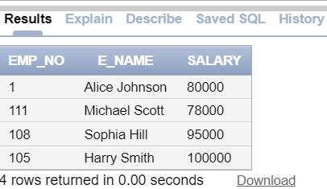ANS:

SELECT Emp_no, E_name,Salary

FROM EMPLOYEE

Designation='MANAGER';

2. Display all the details of the employee whose salary is more than the Sal of any IT PROFF..

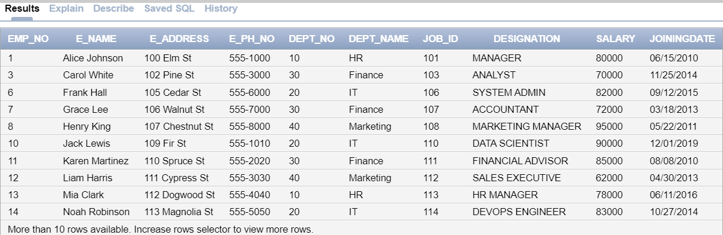 ANS:

SELECT * FROM EMPLOYEE

WHERE Salary > (SELECT MIN(Salary) FROM EMPLOYEE WHERE Designation = 'IT PROFF.');

3. List the employees in the ascending order of Designations of those joined after 1981.

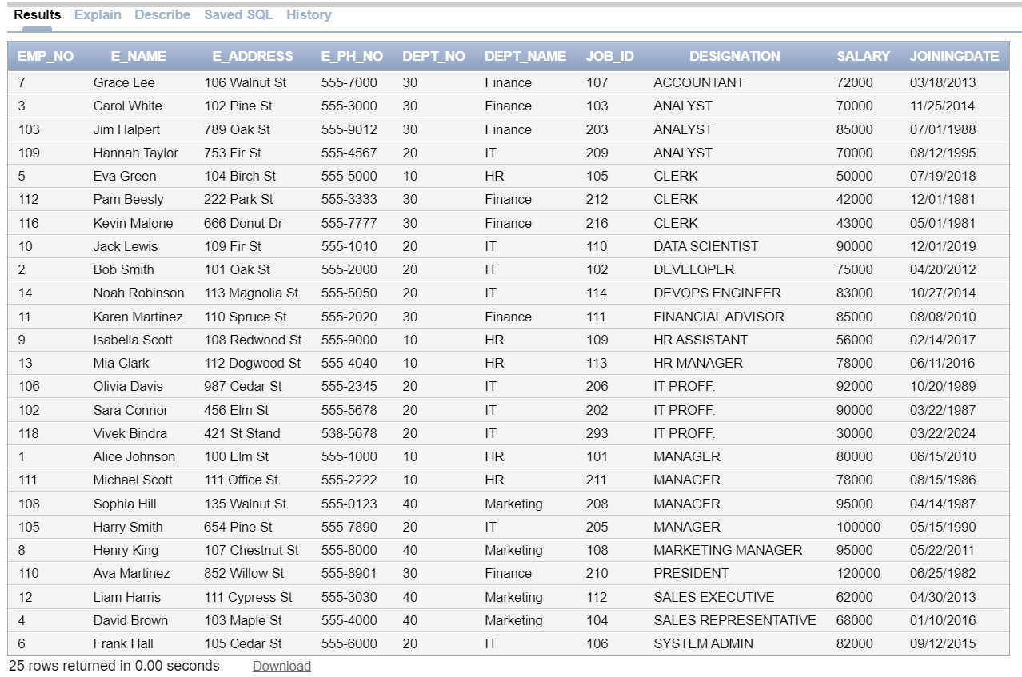ANS:

SELECT *

FROM EMPLOYEE

WHERE Joiningdate > TO_DATE('1981-01-01','YYYY-MM-DD')

ORDER BY Designation ASC;

4. List the employees along with their Experience and Daily Salary.

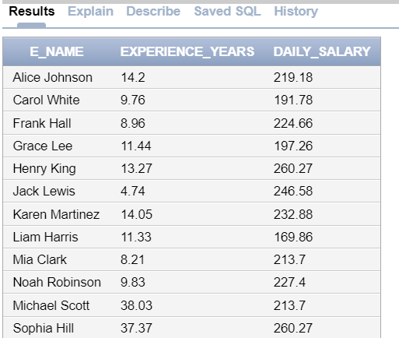 ANS:

SELECT E_name,

ROUND(MONTHS_BETWEEN(SYSDATE, Joiningdate) / 12, 2) AS Experience_Years,

ROUND(Salary / 365, 2) AS Daily_Salary

FROM EMPLOYEE;

5. List the employees who are either ‘CLERK’ or ‘ANALYST’ .

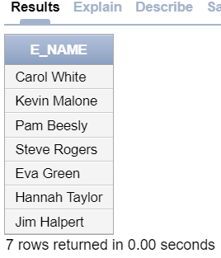 ANS:

SELECT E_name

FROM EMPLOYEE

WHERE Designation='CLERK' OR Designation='ANALYST';

6. List the employees who joined on 1-MAY-81, 3-DEC-81, 17-DEC-81,19-JAN-80

 ANS:

SELECT E_name

FROM EMPLOYEE

WHERE Joiningdate IN (

TO_DATE('01-MAY-1981', 'DD-MON-YYYY'),

TO_DATE('03-DEC-1981', 'DD-MON-YYYY'),

TO_DATE('17-DEC-1981', 'DD-MON-YYYY'),

TO_DATE('19-JAN-1980', 'DD-MON-YYYY')

);

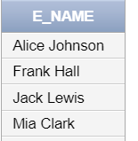7. List the employees who are working for the Deptno 10 or20.

ANS: SELECT E_name

FROM EMPLOYEE

WHERE Dept_no IN (10, 20);

8. List the Enames those are starting with ‘S’

ANS:

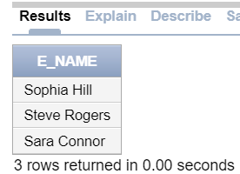

SELECT E_name

FROM EMPLOYEE

WHERE E_name LIKE 'S%';

9. Dislay the name as well as the first five characters of name(s) starting with ‘H’

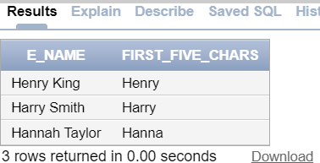 ANS:

SELECT E_name, SUBSTR(E_name, 1, 5) AS First_Five_Chars

FROM EMPLOYEE

WHERE E_name LIKE 'H%';

10. List all the emps except ‘PRESIDENT’ & ‘MGR” in asc order of Salaries

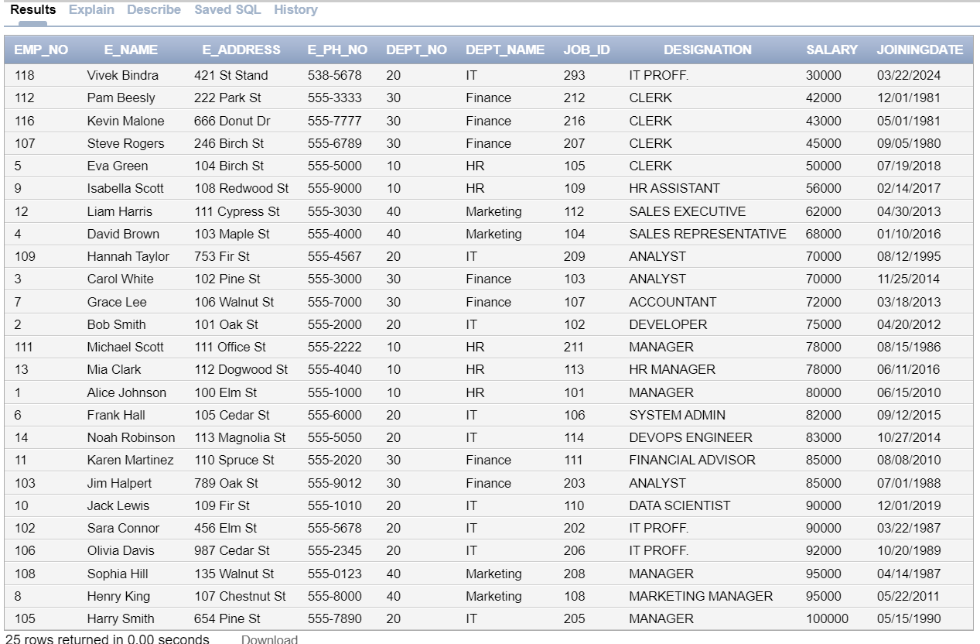 ANS:

SELECT *

FROM EMPLOYEE

WHERE Designation NOT IN ('PRESIDENT', 'MGR')

ORDER BY Salary ASC;